**Task – NodeJS DB operation**

**Instructions**

Task1: Using Handlebar, create HTML page that contains following information

Subject-Code, Subject-Name (Text-box)

Institute-Name (Text-box)

Department-Name (Text-box)

Semester=>Dropdown menu

Task2: Store above information into MySQL database and display.

**Code:**

**Index.hbs layout file**

<!DOCTYPE html>

<html lang="en">

<head>

<meta charset="UTF-8">

<meta http-equiv="X-UA-Compatible" content="IE=edge">

<meta name="viewport" content="width=device-width, initial-scale=1.0">

<link

rel="stylesheet"

href="https://bootswatch.com/5/sketchy/bootstrap.min.css"

/>

<script src="https://bootswatch.com/_vendor/bootstrap/dist/js/bootstrap.bundle.min.js"></script>

<script src="https://bootswatch.com/_vendor/jquery/dist/jquery.min.js"></script>

<script src="https://kit.fontawesome.com/fd15636b22.js" crossorigin="anonymous"></script>

<title>NodeJS with MySQL</title>

</head>

<style>

.mainbox {

margin: 2rem auto;

text-align: center;

}

body{

padding: 1rem;

}

.navbar{

margin: 0.5rem 0.5rem;

}

</style>

<body>

{{> header}}

{{{body}}}

{{>footer}}

</body>

</html>

**Main.hbs file**

<div class="row justify-content-md-center">

<div class="col-md-auto">

<h1>NodeJS</h1>

</div>

</div>

<div class="row justify-content--center">

<div class=" justify-content-center">

<div class="col">

<div class="card border-info mb-3" style="max-width: 30rem;margin: 15rem 10rem;">

<div class="card-header">Add Subject Info</div>

<div class="card-body text-center">

<h4 class="card-text">

<a class="btn btn-info" href="/subject-form">Add Subject</a>

</h4>

</div>

</div>

</div>

</div>

</div>

**Form.hbs file**

<class class="container mainbox">

<div class="row justify-content-md-center">

<div class="col-12">

<p style="font-weight: 800; font-size:2rem">ADD SUBJECT DETAILS</p>

</div>

<div class="col" style="margin: 2rem;padding: 5rem;">

<form name="subject-form" action="/show-data" method="post" class="row g-2" >

<div class="col-md-4 g-5 ">

<label for="subject_code" class="form-label">Subject Code</label>

<input type="text" class="form-control" name="scode" id="subject_code" maxlength="10" required>

</div>

<div class="col-md-4 g-5 ">

<label for="subject_name" class="form-label">Subject Name</label>

<input type="text" class="form-control" name="sname" id="subject_name" required>

</div>

<div class="col-md-4 g-5 ">

<label for="institute_name" class="form-label">Institute Name</label>

<input type="text" class="form-control" name="iname" id="institute_name" required>

</div>

<div class="col-md-4 g-5 ">

<label for="department_name" class="form-label">Department Name</label>

<input type="text" class="form-control" name="dname" id="department_name" required>

</div>

<div class="col-md-4 g-5 ">

<label for="sem" class="form-label">Semester</label>

<select class="form-select" name="sem" id="sem" aria-describedby="sem" required>

<option selected disabled value="">Choose</option>

<option>1</option>

<option>2</option>

<option>3</option>

<option>4</option>

<option>5</option>

<option>6</option>

<option>7</option>

<option>8</option>

</select>

</div>

<div class="col-12 mt-5">

<button class="btn btn-primary" type="submit">Submit form</button>

</div>

</div>

</form>

</div>

</class>

**Showdata.hbs file**

<style>

table, th, td {

border: 1px solid black;

margin-top:20%;

}

</style>

<div class="row justify-content-md-center">

<h1 style="text-align: center; margin-top:5%">Submitted Subject Data</h1>

</div>

<div class="row justify-content-md-center">

<div class="col-md-6">

<table class="table" >

<tr>

<th scope="col">Subject Code</th>

<td>{{data.scode}}</td>

</tr>

<tr>

<th scope="col">Subject Name</th>

<td>{{data.sname}}</td>

</tr>

<tr>

<th scope="col">Institute Name</th>

<td>{{data.iname}}</td>

</tr>

<tr>

<th scope="col">Department Name</th>

<td>{{data.dname}}</td>

</tr>

<tr>

<th scope="col">Semester</th>

<td>{{data.sem}}</td>

</tr>

</table>

</div>

</div>

**Server.js file**

const express=require("express");

const PORT=3000;

const app=express();

const handlebars=require("express-handlebars");

var mysql = require('mysql');

//connection

const connection = mysql.createConnection({

host: 'localhost',

user:'root',

password:'',

database:'Subject'

});

connection.connect((err)=>{

if(err) throw err;

console.log("Connected successfully to MySql server")

});

//create database

const dbquery="CREATE DATABASE IF NOT EXISTS Subject";

connection.query(dbquery,(err,result)=>{

if(err) throw err;

console.log("Database created successfully",result)

})

//create table

const dbtable=`CREATE TABLE IF NOT EXISTS subject(

subjectCode varchar(10) NOT NULL,

subjectName varchar(50) NOT NULL,

instituteName varchar(50) NOT NULL,

departmentName varchar(50) NOT NULL,

semester varchar(1) NOT NULL,

PRIMARY KEY (subjectCode))`

// SHOW DATABASES => List the available DB from MySql server

connection.query("USE Subject",(err,result)=>{ // "Select Database"

if(err) throw err;

connection.query(dbtable,(err,result)=>{

if(err) throw err;

console.log("Table created successfully",result)

});

});

//middleware

app.use(express.static("public"));

app.use(express.urlencoded({extended:false}));

app.set('view engine', 'hbs');

app.engine("hbs",handlebars({

layoutsDir:`${__dirname}/views/layouts`,

extname:"hbs",

defaultLayout:"index",

partialsDir:`${__dirname}/views/partials`

}))

app.get("/",(req,res)=>{

res.render("main");

});

app.get("/subject-form",(req,res)=>{

res.render("form");

});

app.post("subject-form",(req,res)=>{

res.redirect("/show-data")

});

app.post("/show-data",(req,res)=>{

// console.log(req.body);

var subjectCode = req.body.scode;

var subjectName = req.body.sname;

var instituteName = req.body.iname;

var departmentName = req.body.dname;

var semester=req.body.sem;

var sql = `INSERT INTO subject (subjectCode, subjectName, instituteName, departmentName, semester) VALUES ("${subjectCode}", "${subjectName}", "${instituteName}", "${departmentName}","${semester}")`;

connection.query(sql, function(err, result) {

if (err) throw err;

console.log('record inserted');

res.render("showdata",{data:req.body});

});

})

app.get("/stored-data",(req,res)=>{

const dbInsert=`SELECT * from subject`;

connection.query("USE Subject",(err,result)=>{

if(err) throw err;

connection.query(dbInsert,(err,result)=>{

if(err) throw err;

console.log("Inserted Data is");

console.log(result);

res.send(result);

})

})

})

app.use( (req,res,next)=>{

res.render("404");

})

app.listen(PORT,()=>{

console.log(`Server is listening on port ${PORT}`);

})

**File structure**

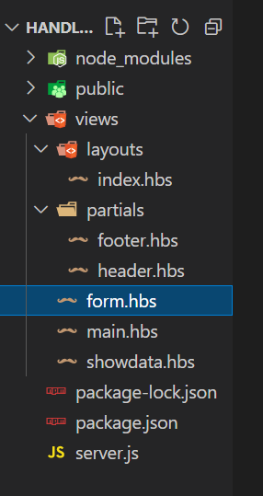

**OUTPUT**

Home page

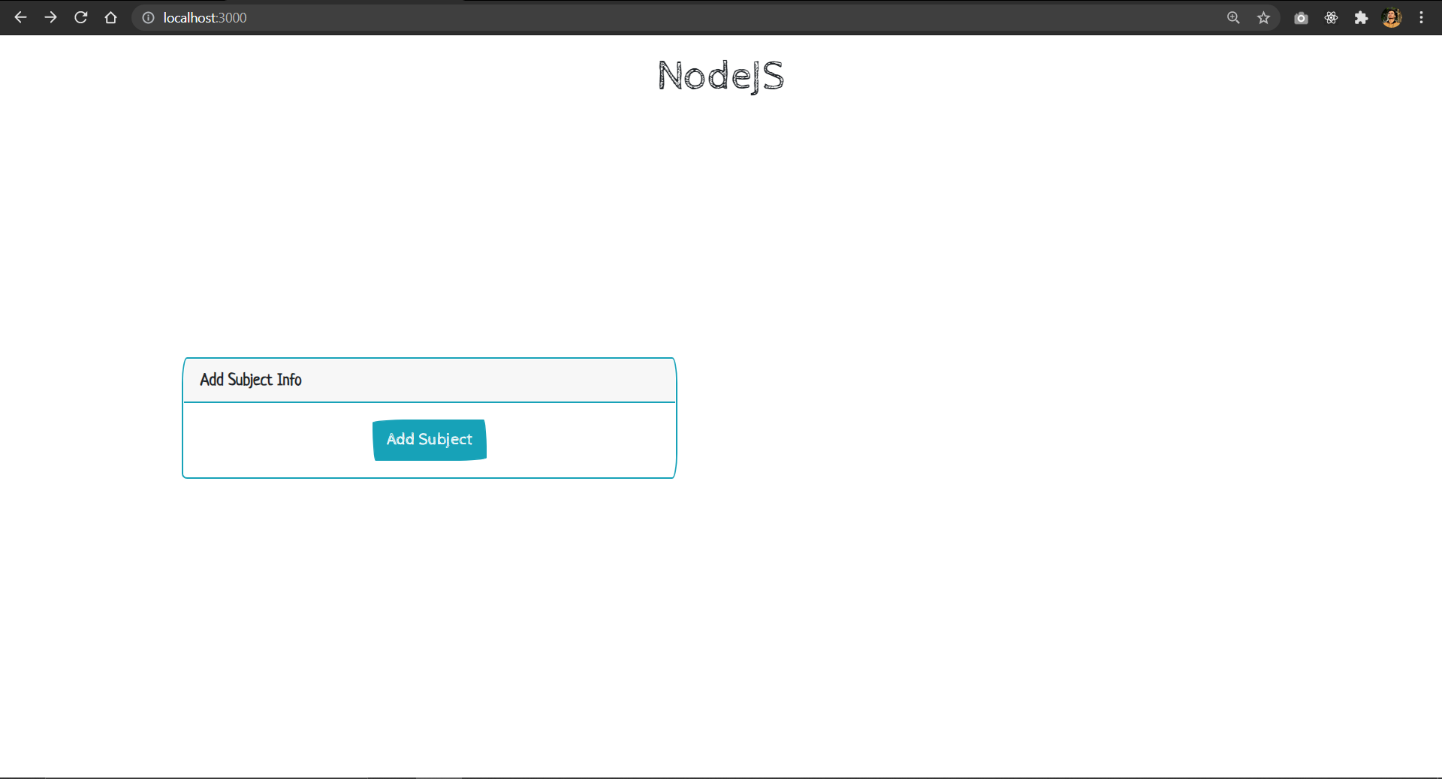

Form page

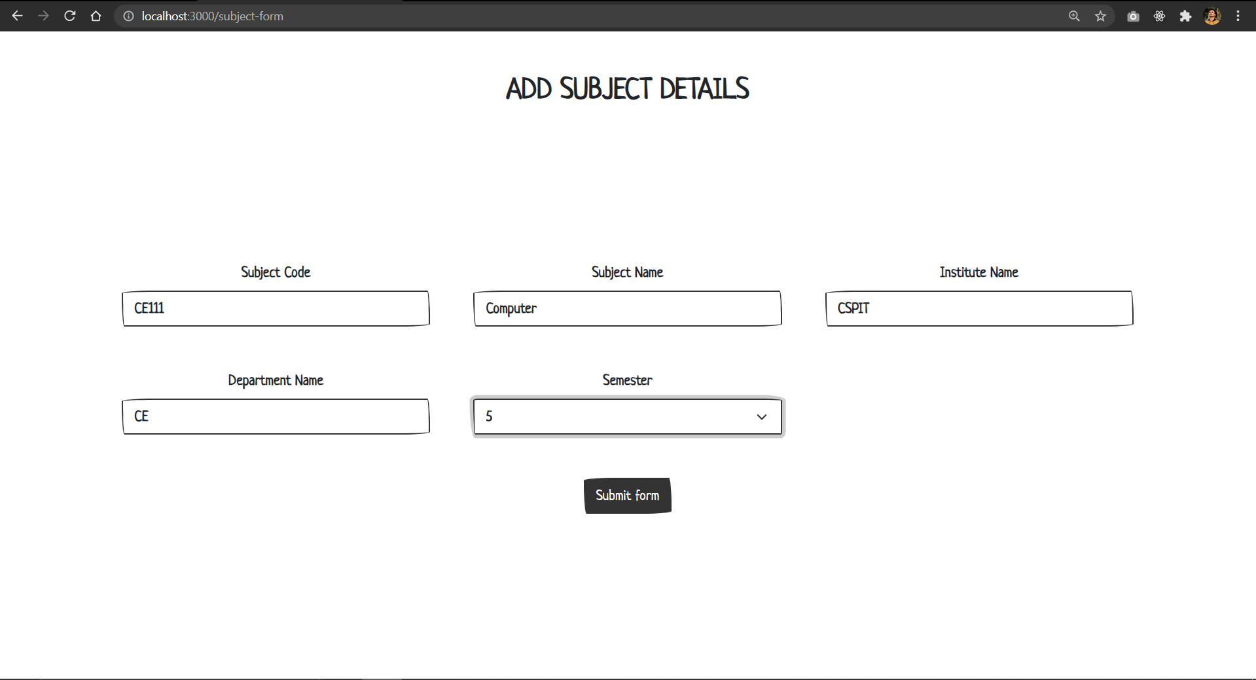

Display the data

